Program 5: Maven Selenium Project – Automating Login on SauceDemo (Chrome)
Procedure
Step 1: Create Maven Project
mvn archetype:generate -DgroupId=com.example -DartifactId=MyMavenSeleniumChrome3 \
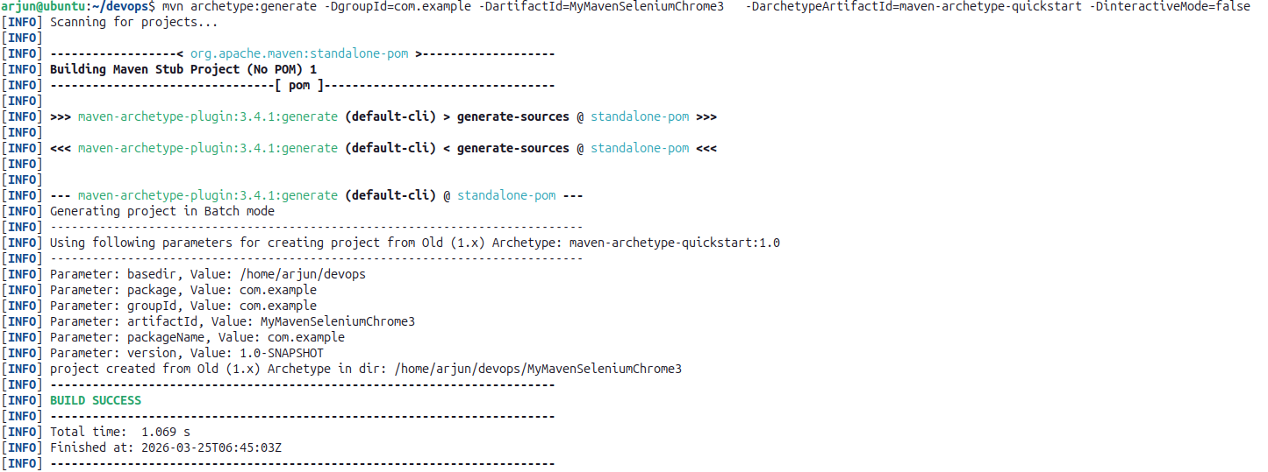
-DarchetypeArtifactId=maven-archetype-quickstart -DinteractiveMode=false

Step 2: Navigate to the Project Directory
cd MyMavenSeleniumChrome3
tree
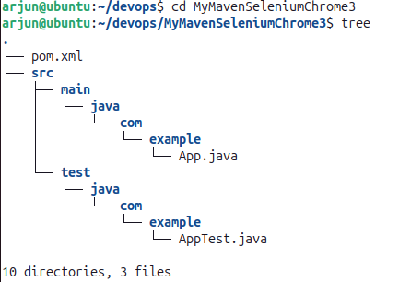

Step 3: Inspect Elements on SauceDemo
Open https://www.saucedemo.com/ in Chrome. Right-click → Inspect. Identify: user-name, password, login-button.
HTML Elements Used
Field | ID Attribute
Username Input | user-name
Password Input | password
Login Button | login-button
Login Credentials: Username: standard_user | Password: secret_sauce
Step 4: Edit pom.xml
gedit pom.xml
pom.xml
<project xmlns="http://maven.apache.org/POM/4.0.0"
xmlns:xsi="http://www.w3.org/2001/XMLSchema-instance"
xsi:schemaLocation="http://maven.apache.org/POM/4.0.0
http://maven.apache.org/maven-v4_0_0.xsd">
<modelVersion>4.0.0</modelVersion>
<groupId>com.example</groupId>
<artifactId>MyMavenSeleniumApp01</artifactId>
<packaging>jar</packaging>
<version>1.0-SNAPSHOT</version>
<name>MyMavenSeleniumApp01</name>
<url>http://maven.apache.org</url>
<dependencies>
<dependency>
<groupId>junit</groupId>
<artifactId>junit</artifactId>
<version>3.8.1</version>
<scope>test</scope>
</dependency>
<!-- Selenium: Browser automation library -->
<dependency>
<groupId>org.seleniumhq.selenium</groupId>
<artifactId>selenium-java</artifactId>
<version>4.29.0</version>
</dependency>
</dependencies>
<build>
<plugins>
<plugin>
<groupId>org.apache.maven.plugins</groupId>
<artifactId>maven-compiler-plugin</artifactId>
<version>3.8.1</version>
<configuration>
<source>1.7</source>
<target>1.7</target>
</configuration>
</plugin>
<plugin>
<groupId>org.apache.maven.plugins</groupId>
<artifactId>maven-surefire-plugin</artifactId>
<version>2.22.2</version>
</plugin>
<plugin>
<groupId>org.apache.maven.plugins</groupId>
<artifactId>maven-jar-plugin</artifactId>
<version>3.0.1</version>
<configuration>
<archive>
<manifestEntries>
<Main-Class>com.example.App</Main-Class>
</manifestEntries>
</archive>
</configuration>
</plugin>
</plugins>
</build>
</project>

Step 5: Modify App.java
cd src/main/java/com/example/
gedit App.java
App.java
package com.example;
import org.openqa.selenium.By;
import org.openqa.selenium.WebDriver;
import org.openqa.selenium.chrome.ChromeDriver;

public class App {
public static void main(String[] args) throws InterruptedException {
// Initialize ChromeDriver and open browser
WebDriver driver = new ChromeDriver();
driver.manage().window().maximize();

// Open SauceDemo login page
driver.get("https://www.saucedemo.com/");
Thread.sleep(3000);

// Enter username
driver.findElement(By.id("user-name")).sendKeys("standard_user");

// Enter password
driver.findElement(By.id("password")).sendKeys("secret_sauce");

// Click the login button
driver.findElement(By.id("login-button")).click();
Thread.sleep(3000);

driver.quit();
}
}

Step 6: Compile and Run
mvn clean install
mvn exec:java -Dexec.mainClass="com.example.App"
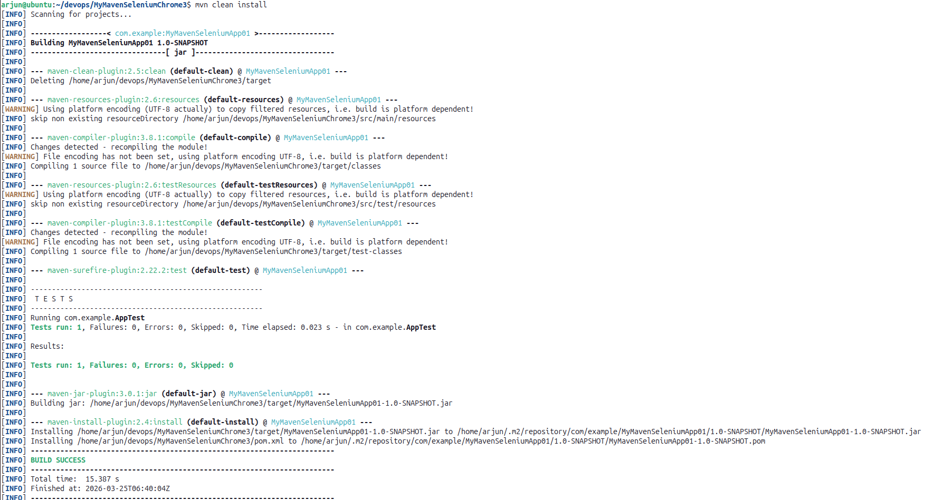

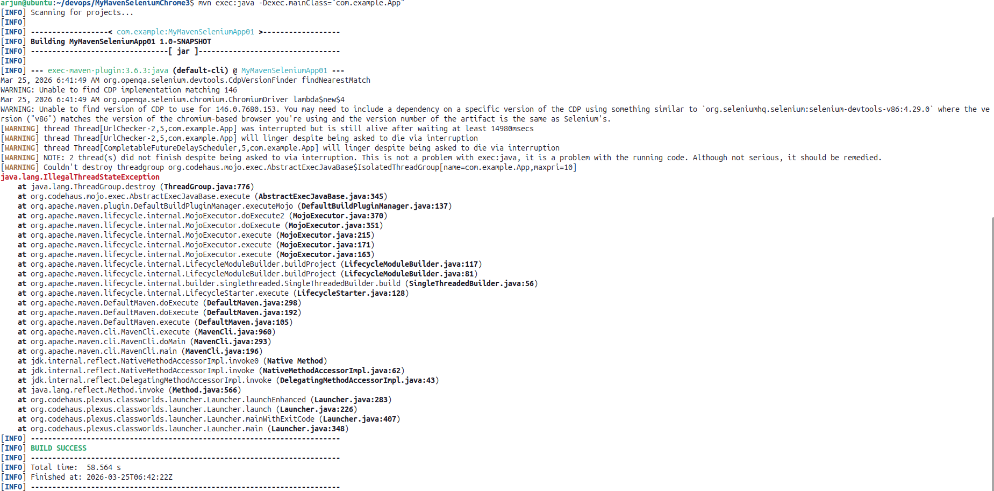

Output
Chrome browser launches, opens the SauceDemo login page, enters standard_user in the username field and secret_sauce in the password field, clicks the login button, and the products page loads confirming successful login. Browser closes after 3 seconds. Terminal shows BUILD SUCCESS.

